|  |  |
| --- | --- |
| DATE | 20-10-22 |
| TEAM ID | PNT2022TMID21330 |
| PROJECT NAME | Containment-zone-Alerting-App |

**INSTALLATION OF ANDROID STUDIO**

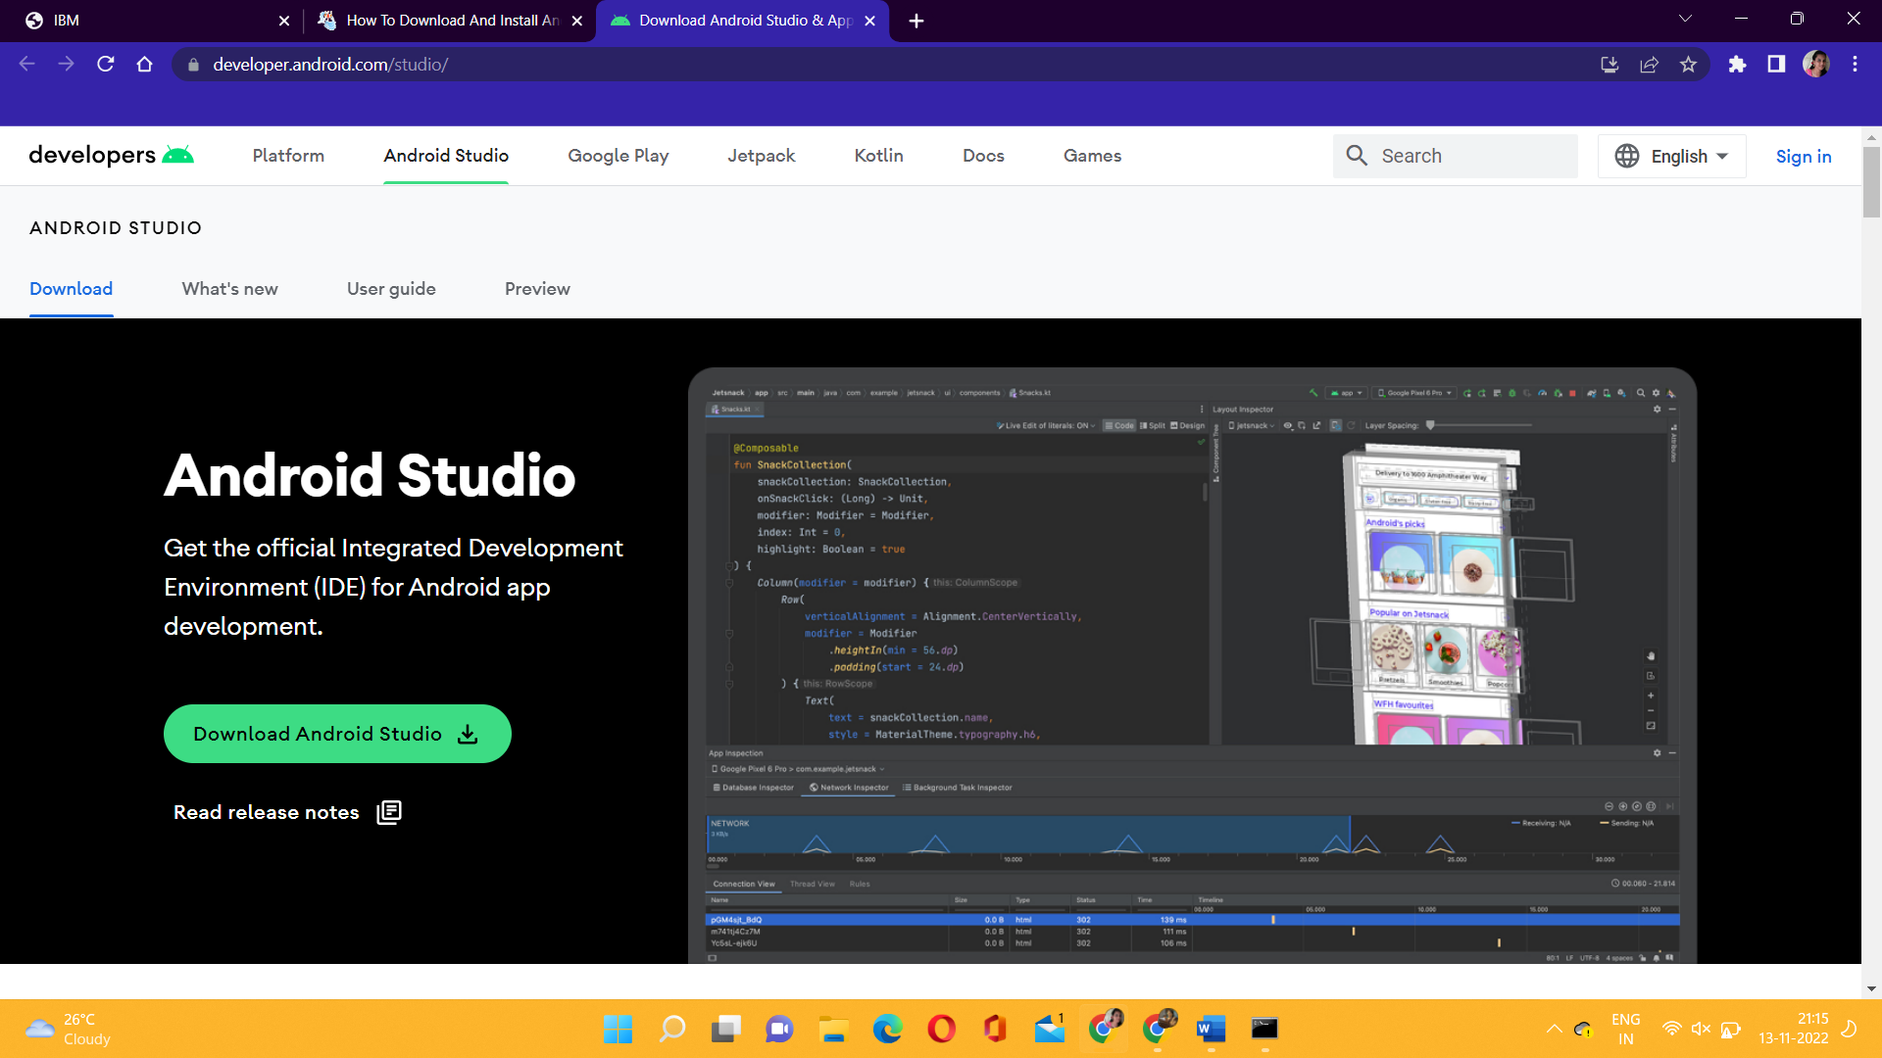

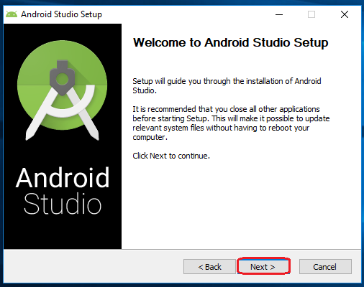

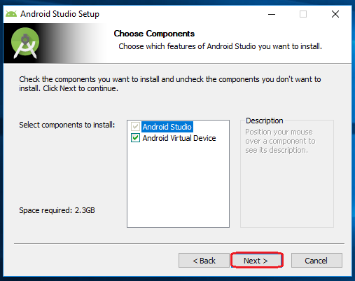

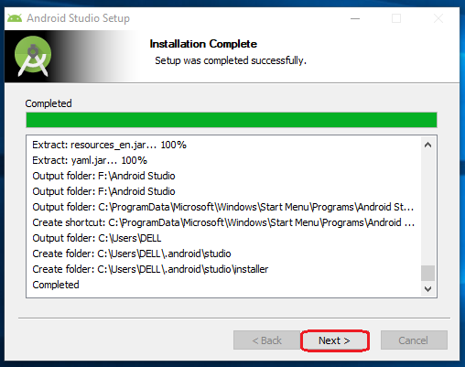

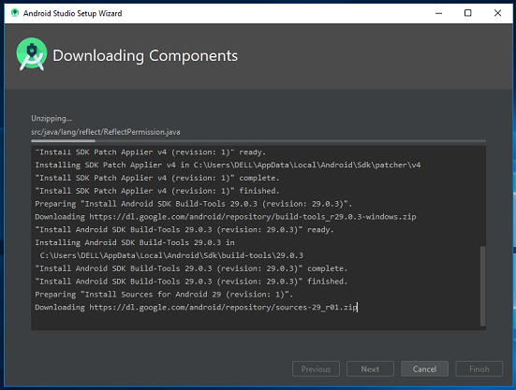

**Create an android application**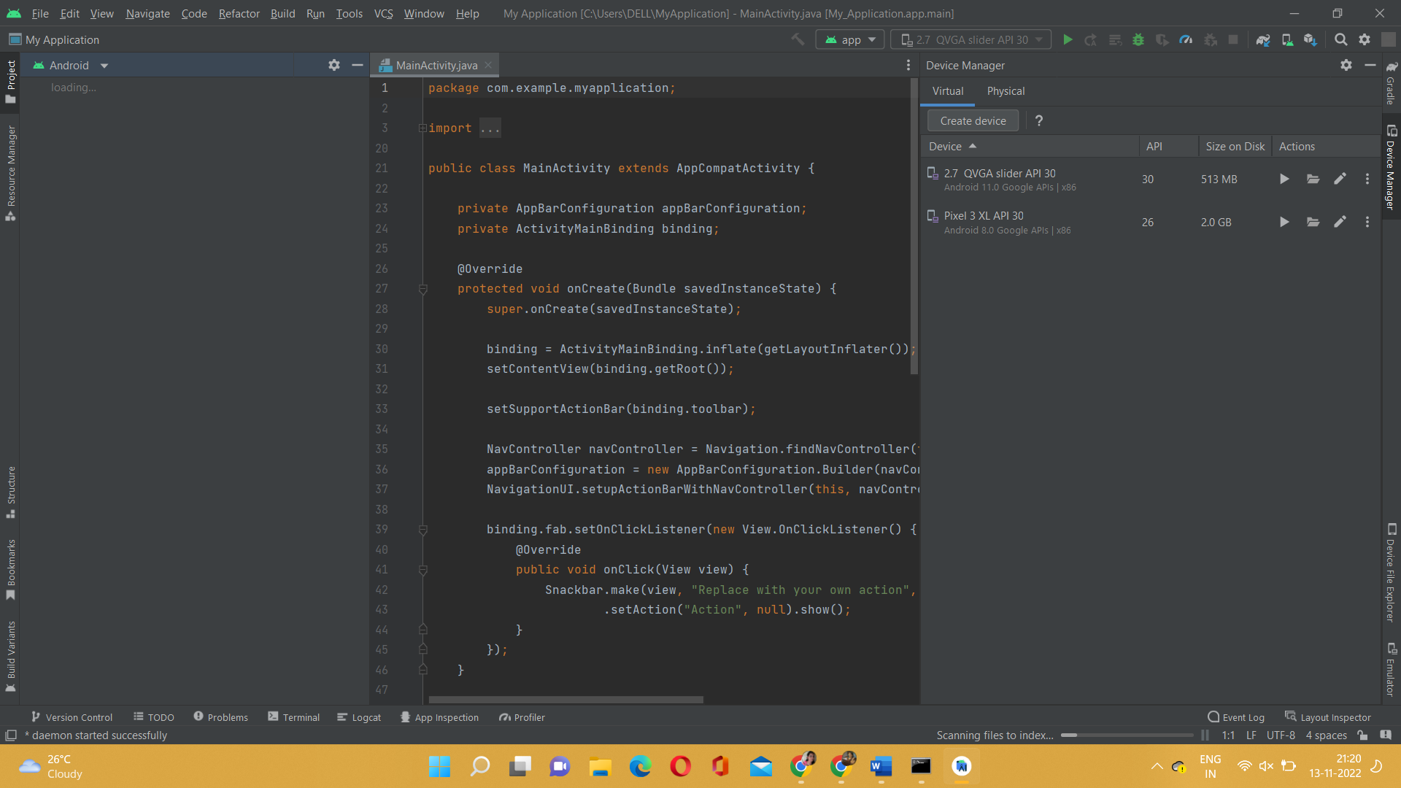

**Enable Location Services To Application**

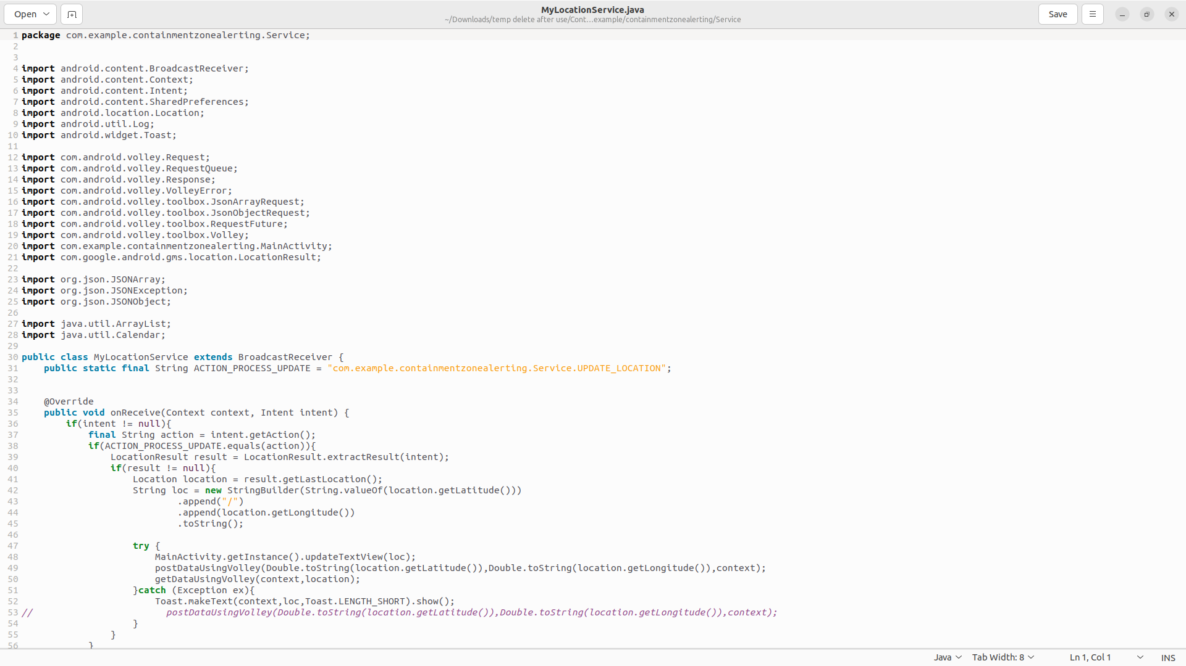

**Geofence in Android App**

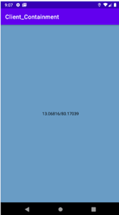

**Build the APK file for the project**

